8) COnfigure Nat gateway in public subnet and connect to private Instance

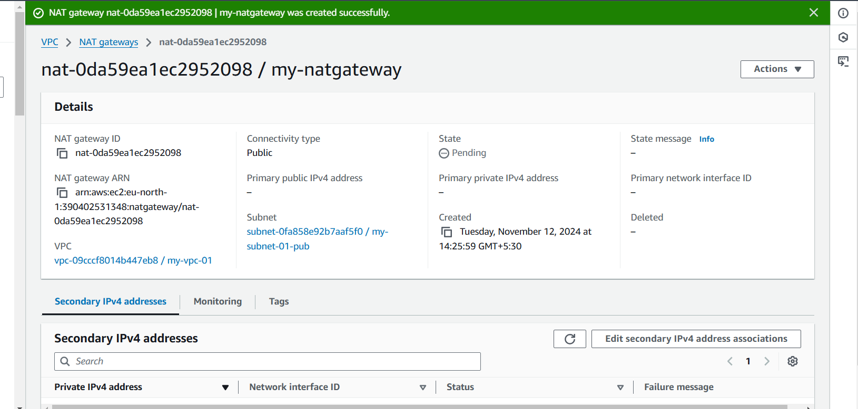

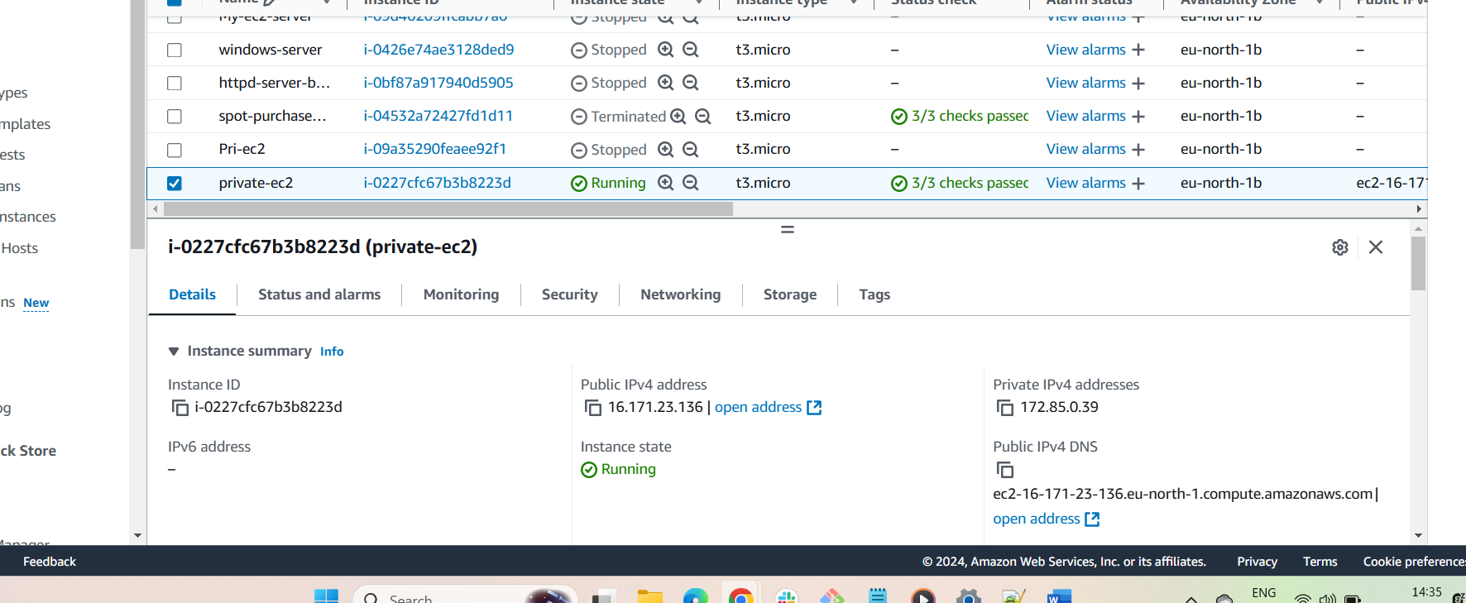

9) Install Apache Tomcat in private ec2 and deploy a sample app.

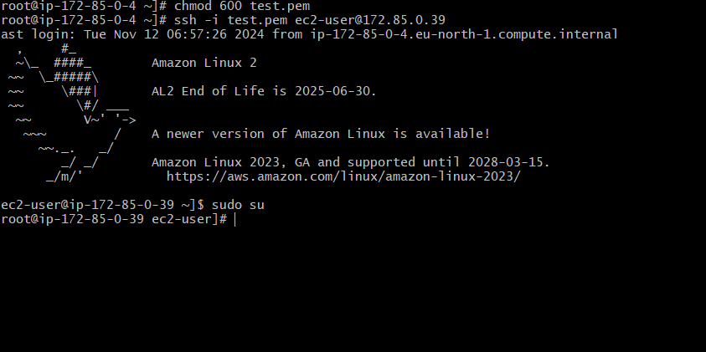

* 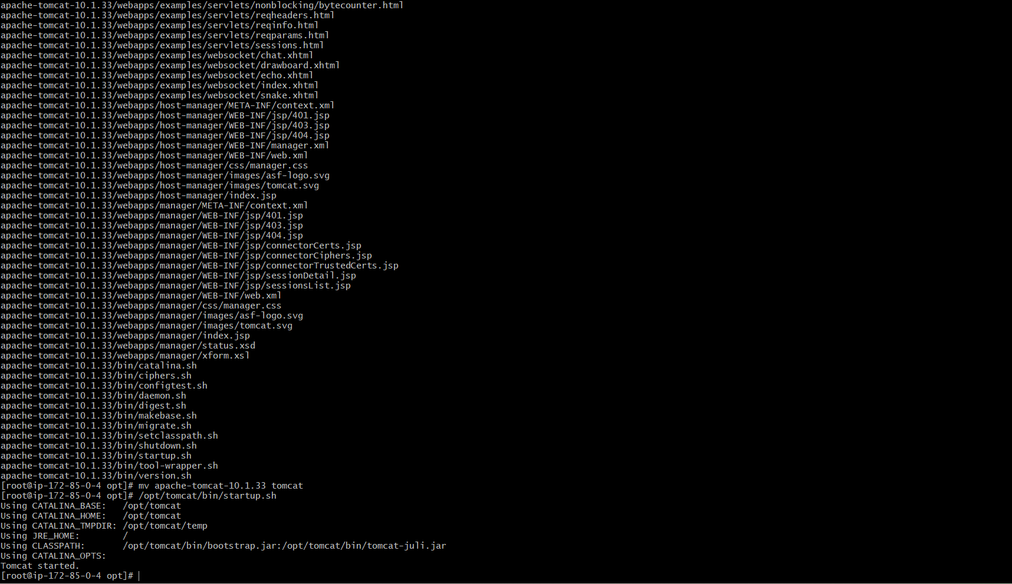

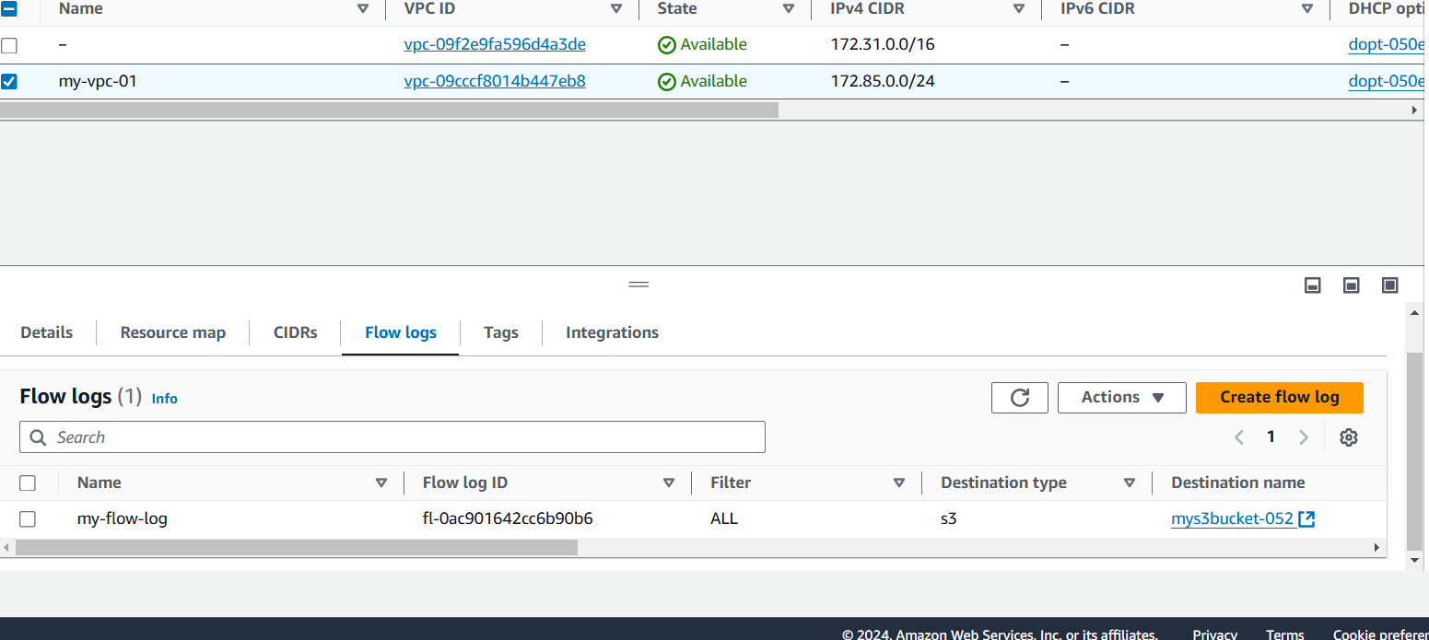

10) COnfigure VPC flow logs and store the logs in s3 and cloudwatch.

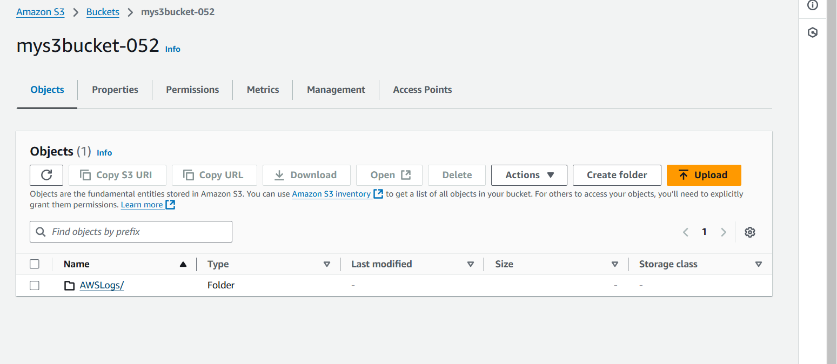

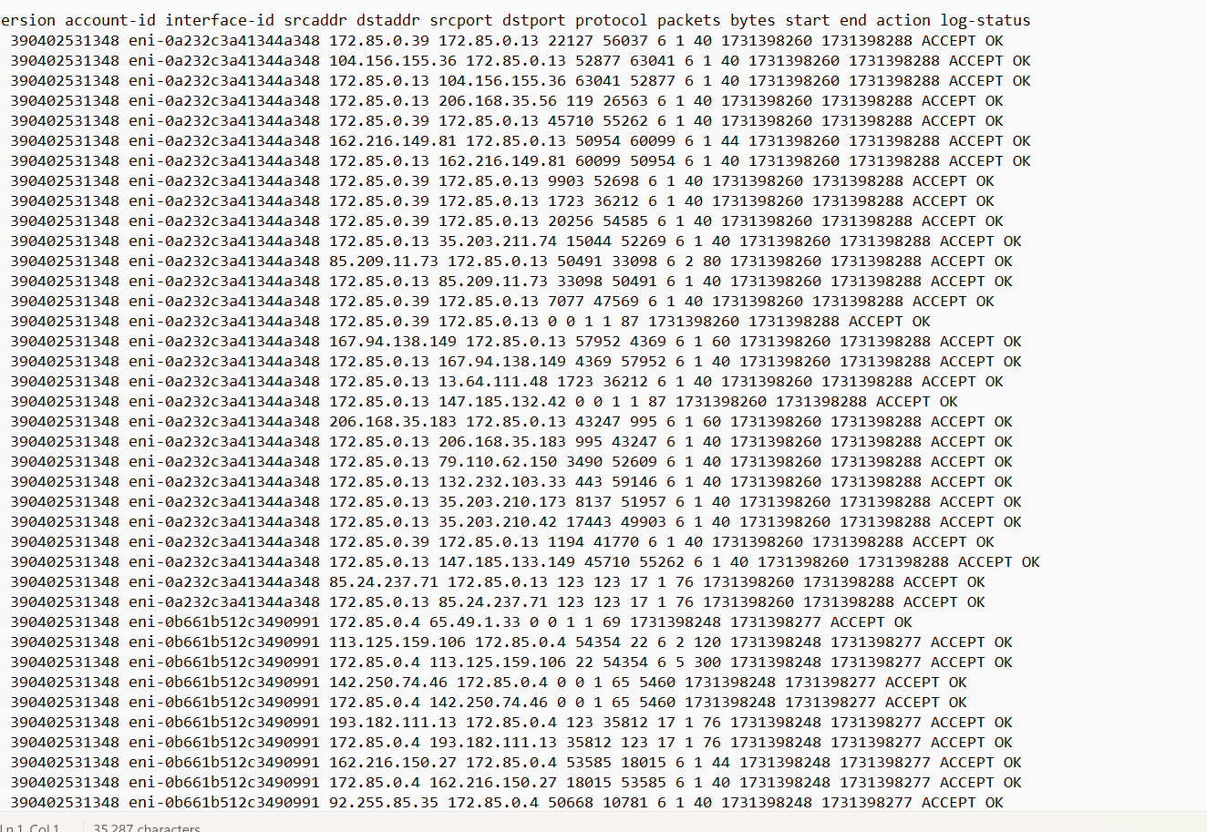

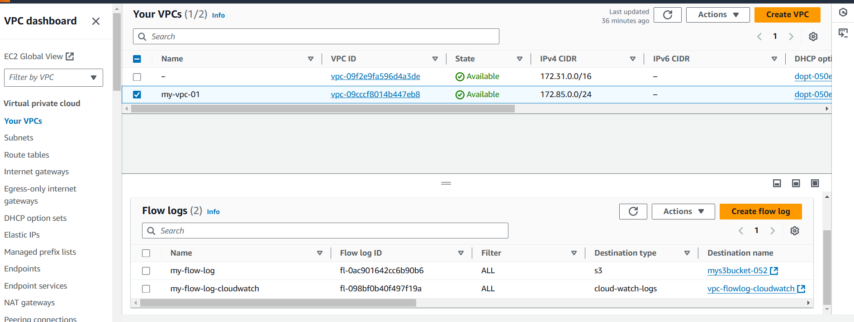

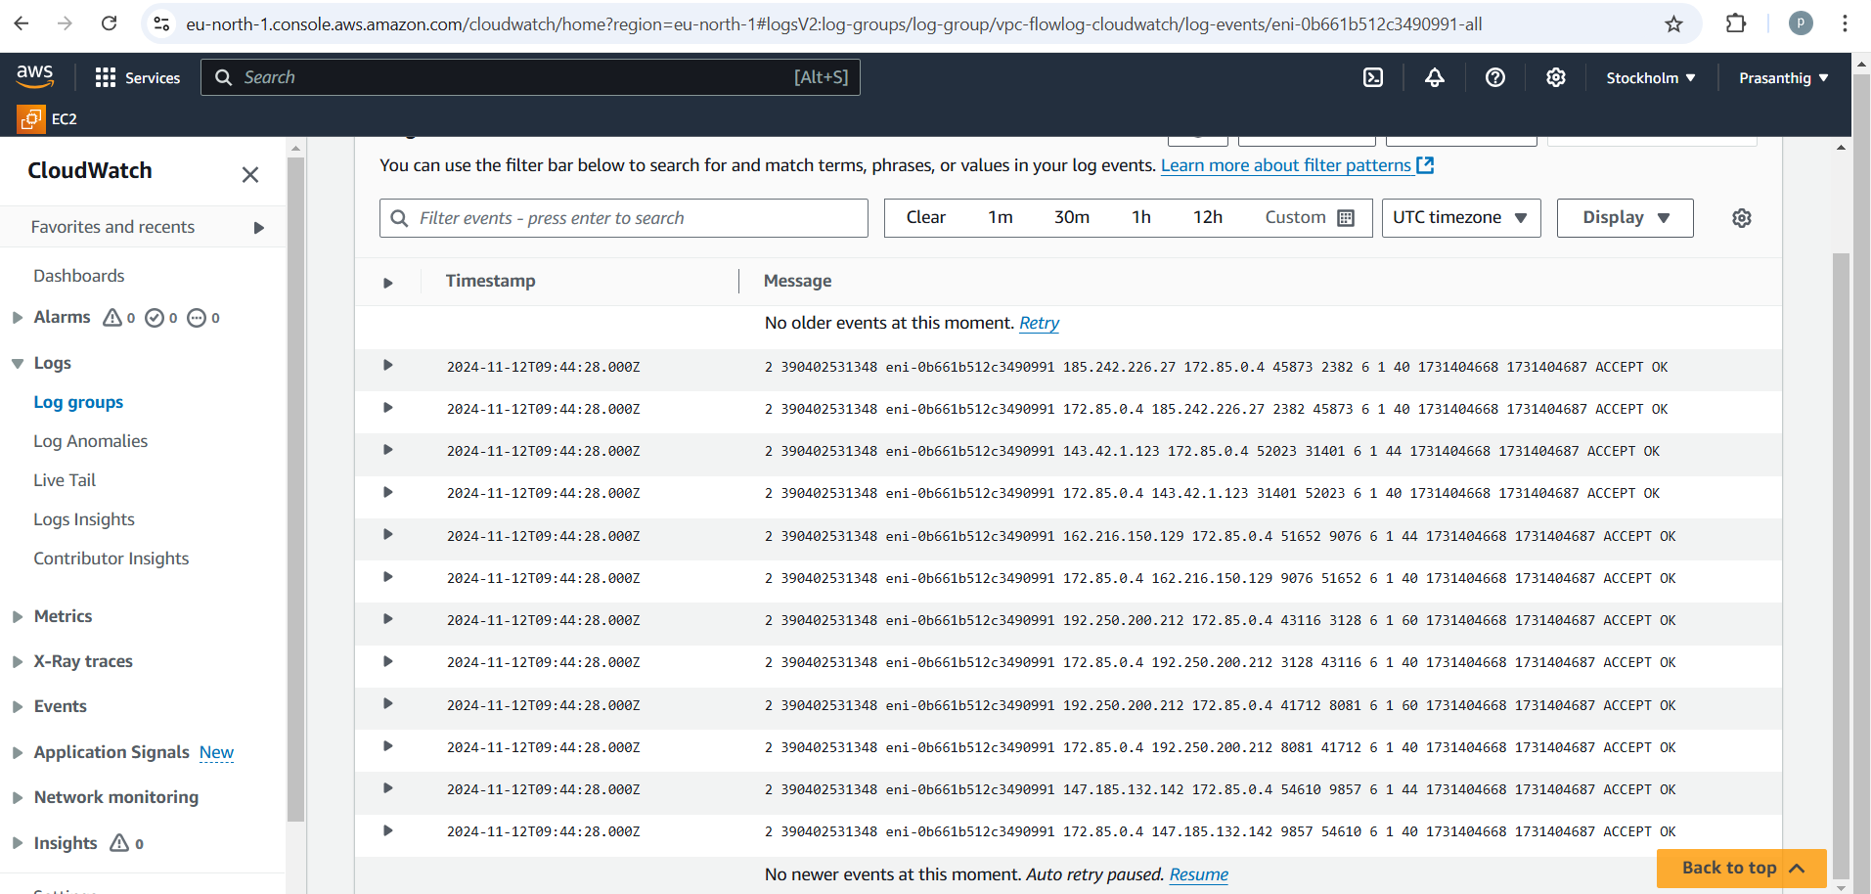

1. Create one VPC,with 1 one public subnet and 1 private subnet.

Create a VPC

Create 2 subnets

One for public and other for private

Create a route table and go to subnet associations add the subnet created

Provide internet gateway to the public subnet

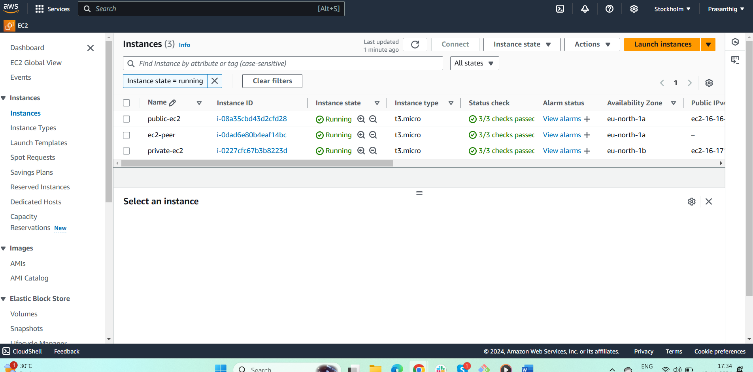

1. Enable VPC peering for cross region.

Create a peer connection in one region from where we have to connect to other vpc

Provide the VPC ID of both requester and acceptor

And requested to be accepted from other region

After accepting the request

Go to route table and allow the other region Ips in both regions

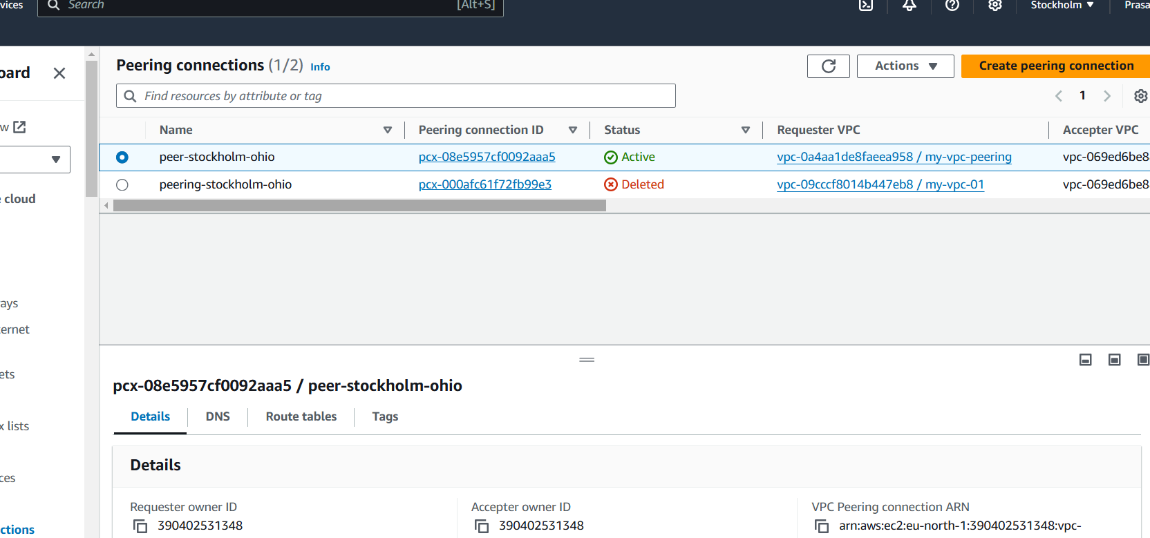

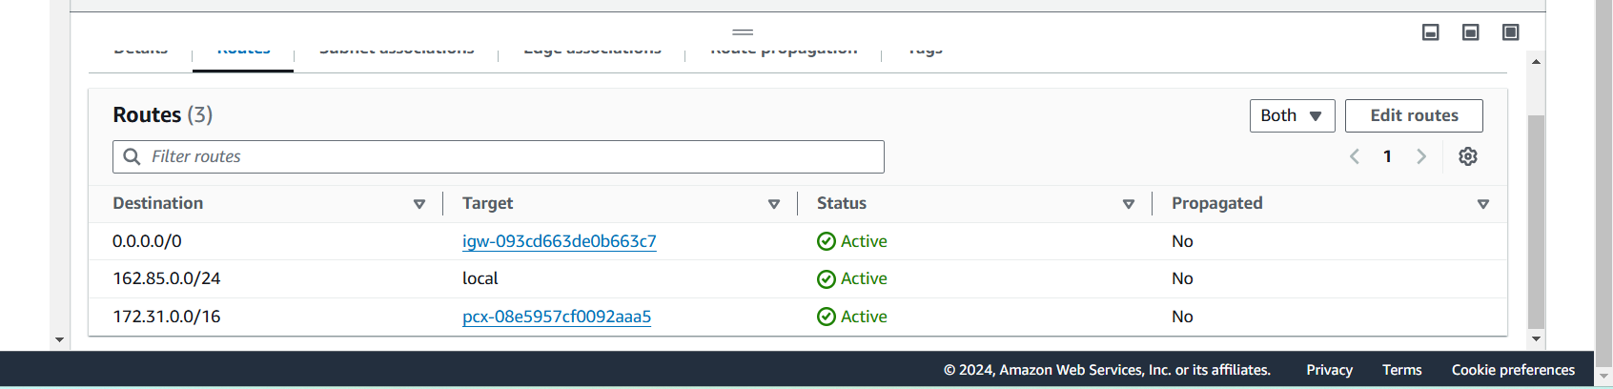

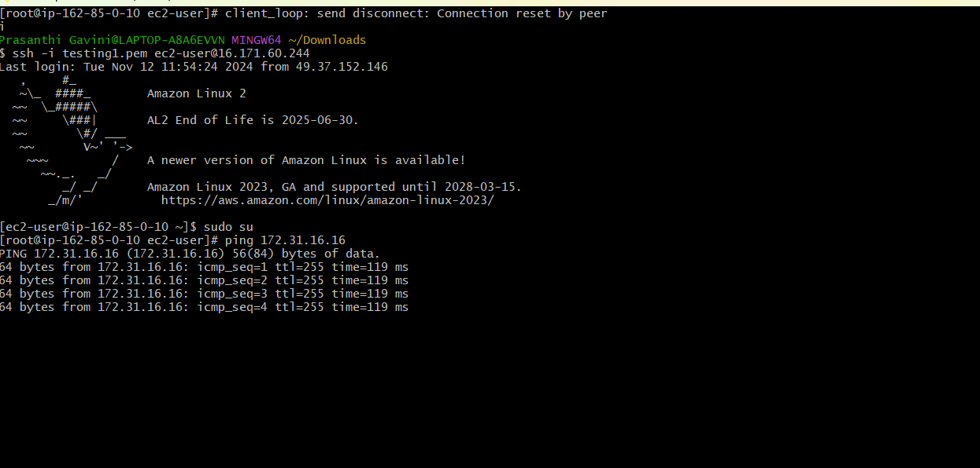

3) Enable VPC peering for cross account. (You can collaborate with your friend and do this task).

